 | IQVIA Work Instruction  Global Regulatory Affairs – Marketing Authorisation Renewal
Document Number and Revision:
CS_WI_RA0274 Revision 4
Document Owner:  Anja De Pauw |  | Author(s):  Tamara Lewicky

PURPOSE

To outline the procedure for applications to a Regulatory Authority (RA) for renewal of product authorisations.

SCOPE

  - Applies to all IQVIA Global Regulatory Affairs (GRA) staff.

  - Applies to pharmaceutical product registrations globally except the United States of America (USA) which has no renewal process.

  - Does not apply to annual reassessment applications of medicinal products authorized under exceptional circumstances.

  - Does not apply to annual renewal application of conditional marketing authorisations (CMA)

  - Applies to the CMA and to marketing authorisation under exceptional circumstances once converted into a standard marketing authorisation (not subject to specific obligations) which will initially be valid for a defined number of years depending on the country, and can be renewed for unlimited validity in many of them. Applicable local Regulation is to be checked for confirmation.

ROLES AND RESPONSIBILITIES
The following roles perform tasks described within this Work Instruction (WI):
Role | Sections
Regulatory Project Manager (RPM) | 6.1, 6.2, 6.4, 6.6
Regulatory Team Members (RTM) | 6.2, 6.4, 6.5
Regulatory Affairs Writer (RAW) | 6.3
Regulatory Affairs Quality Control Reviewer (RAQCR) | 6.3

DEFINITIONS
Not Applicable

MATERIAL AND EQUIPMENT
Not Applicable

PROCEDURE

  - Project Management Planning
Preparation of the Project Plan (PP) may not be required where the Customer is responsible for preparing and maintaining the PP.

No: | Who: | Step: | When:
6.1.1 | RPM | Requests the Customer to provide general information related to the concerned products that may impact the Renewal timeline, such as but not limited to, registration expiration date, submission deadlines, and ongoing or planned variations, in each country involved.  Includes the information in the Renewal timeline tracker that will be prepared as a part of the PP, and any other additional information, as applicable. | At project initiation
6.1.2 | RPM | Develops a PP for Renewals in a format agreed with the Customer, with the following minimum required information:  - The list of deliverables (products by country)  - Key timelines and milestones for various tasks  - Responsibility of preparing submission-ready dossiers, whether by RTM or by any other Department in IQVIA, or by a third party  - Format of the dossier  - Customer’s approval process of the renewal dossier and its documentation  - The frequency of updating the PP as agreed with the Customer  - Method to be used for delivering Renewal dossiers and final dossiers throughout the project, e.g. email or shared drive/folder  - Issues impacting deliverables, identification of risks, severity and mitigation/ action plan, as well as any other information required by the Customer, as applicable.  - Method to be used for approval of the PP, i.e. by email or hard copy. | At project initiation
6.1.3 | RPM | Provides the PP to the Customer for review and approval. Updates the PP as needed and obtains the Customer’s final approval | Before starting with project activities
6.1.4 | RPM | Distributes the final PP to the RTM and provides training to the RTMs related to the tasks and timelines of the deliverables and maintains a record of the same. | After receipt of customer approval of the PP
6.1.5 | RPM | Tracks the Renewal requests received from the Customer in a Renewal timeline tracker (or report from a Regulatory Information Management (RIM) system) and alerts the RTM in advance of the submission due date for the Renewal application for each country. | At least 6 months before the submission due date, or earlier as per country- specific requirements

  - Project Execution

No: | Who: | Step: | When:
6.2.1 | RPM | Documents and reports deviations from the agreed PP to the Customer, as well as the rationale and remediation action, in accordance to CS_WI_RA0270 (Global Regulatory Affairs - Quality Oversight) | During execution, as applicable
6.2.2 | RPM or designee | Maintains the Renewal timeline tracker and reviews the tracker to keep track of Renewal due dates and to take the necessary actions. | At least monthly
6.2.3 | RPM | Provides updates to the Customer on the status of Renewals, where required | Whenever requested
6.2.4 | RPM | Reviews and assesses the progress of the project, in particular upcoming submission deadlines, and takes appropriate action on observing any major deviations from the PP, thereby providing the necessary oversight, to identify upcoming renewals. The exception would be where the Customer’s system is being used for tracking renewals. | At least monthly during the course of the project
6.2.5 | RTM | Updates the renewal as per the requirements in the RIM system or Renewal timeline tracker as per current regulations prevailing in the respective country. | During execution
6.2.6 | RTM | Prepares a checklist of regulatory requirements and performs a gap analysis of which documents are required for preparation of the Renewal dossiers for the countries specified. | At planning phase of renewal for a country
6.2.7 | RTM | Identifies the documents / information that are required from the Customer, highlighting those that may take a longer time to be obtained. Examples include:  - Local Pharmacovigilance responsible person  - Specimens of Labels  - Clinical Overview or Clinical Overview addendum,  - Certificate of Pharmaceutical Product (CPP) which may need to be legalized/notarized  - Good Manufacturing Practice (GMP) certificate, which may need to be legalized/notarized, and may need to be issued by the Health Authority for the specific renewal  - Samples requirement and timelines of obtaining them including customs clearance and processing | Approx. 6 months prior to the planned renewal submission date
6.2.8 | RTM | Requests the documents directly from the project team and/or the Customer, as agreed with the Customer.  Note: Requested documents may also include the Customer’s templates and letterhead paper, as appropriate. | During preparation of the dossier
6.2.9 | RTM | Follows up the receipt of source documents/ information from the Customer and keeps the Customer alerted on delays that may impact IQVIA’s deliverables, unless otherwise agreed and documented in the PP. | During preparation of the dossier

  - Dossier Preparation and Review

No: | Who: | Step: | When:
6.3.1 | RAW | Follows CS_WI_RA032 (Global Regulatory Affairs - Preparation, Quality Control and Provision of Regulatory Affairs Deliverables) to prepare the Renewal dossier based on the country’s regulatory | Initial documents received

No: | Who: | Step: | When:
 |  | requirements and using the source documents/ information provided by the Customer.
6.3.2 | RAQCR | Performs the QC review of a Renewal dossier as per CS_WI_RA032 (Global Regulatory Affairs - Preparation, Quality Control and Provision of Regulatory Affairs Deliverables). | After preparation of the dossier
6.3.3 | RAW | Requests translation following CS_WI_RA0262 (Global Regulatory Affairs - Translation of documents) and/ or legalisation of documents to the Customer or to IQVIA’s vendors, if required. | After QC review and update, if any

  - Renewal Dossier Submission

No: | Who: | Step: | When:
6.4.1 | RTM or designee | Prepares the Submission-ready dossier, as per the PP. | After finalization of the approved renewal dossier
6.4.2 | RPM or designee | Finalizes the Submission-ready dossier (e.g. paper, electronic Common Technical Document (eCTD), Non-eCTD electronic Submissions (NeeS)), discusses any observations with the Customer to seek clarification or acceptance, and documents discussions as agreed in the Project Instruction. | After completion of QC
6.4.3 | RTM | Files the final dossier in the IQVIA project folder and, if agreed with the Customer, in the Customer’s systems. | After finalization of the dossier
6.4.4 | RPM/ RTM | Submits the Submission-ready dossier either to the Customer or to the RA.  Note: Distribution to the customer is the responsibility of the RPM, while distribution to the RA is the responsibility of the RTM. | After dossiers are submission ready
6.4.5 | RTM | Provides proof of submission to the Customer if the submission to the RA is performed by IQVIA. Files a copy of the proof of submission on the project folder. | After submission to the RA

  - Post-submission follow-up with Regulatory Authority

The actions in this section only apply if IQVIA is contracted to provide post- submission follow up with the RA.

No: | Who: | Step: | When:
6.5.1 | RTM | Follows up with the RA, as per country specific procedures, on the status of the submitted dossier (e.g. review ongoing, questions, renewed) and keeps the Customer informed. | Post-submission to RA
6.5.2 | RTM | Provides support in preparation of responses to questions/ additional information requested by the RA. | Post-submission, if queries raised by RA
6.5.3 | RTM | Follows renewal outcome with the RA if applicable | Post-submission to RA
6.5.4 | RTM | Informs the Customer as soon as RA Renewal communication is received | Post-approval

  - Lessons Learned

No: | Who: | Step: | When:
6.6.1 | RPM | May organize a ‘lessons learned’ meeting with internal and/or Customer project teams (refer to CS_WI_RA0273 Global Regulatory Affairs - Project Management of Standalone Projects) | At appropriate intervals throughout the Renewal process or at project close-out

- SUPPORTING DOCUMENTATION

DOCUMENT NUMBER | TITLE
ESOP References
7.1 CS_WI_RA032 | Global Regulatory Affairs - Preparation, Quality Control and Provision of Regulatory Affairs Deliverables
7.2 CS_WI_RA0270 | Global Regulatory Affairs - Quality Oversight
7.3 CS_WI_RA0273 | Global Regulatory Affairs - Project Management of Standalone Projects
7.4 CS_WI_RA0262 | Global Regulatory Affairs - Translation of documents

- SUPERSEDES

DOCUMENT NUMBER | TITLE | REVISION NUMBER
8.1 CS_WI_RA0274 | Global Regulatory Affairs - Marketing Authorisation Renewal | 3

- MODIFICATION FROM PREVIOUS REVISION

CHANGE | SECTION REFERENCE | JUSTIFICATION
Replaced “renewal period of 5 years” to “period depending on the country”. | 2.5 | To ensure that local renewal periods are applied in each region.
General review of the document | 6.1, 6.2, 6.3, and 6.4 | Rewording and alignment of activities and redistribution to ensure proper sequencing
Removal of the role “GRA Management GRAM” | 3.0 and 6.1 | For clarity and consistency with other RA SOPs

- APPENDICES

  - Appendix A: Workflow – Marketing Authorisation Renewals

Appendix A: Workflow – Marketing Authorisation Renewals
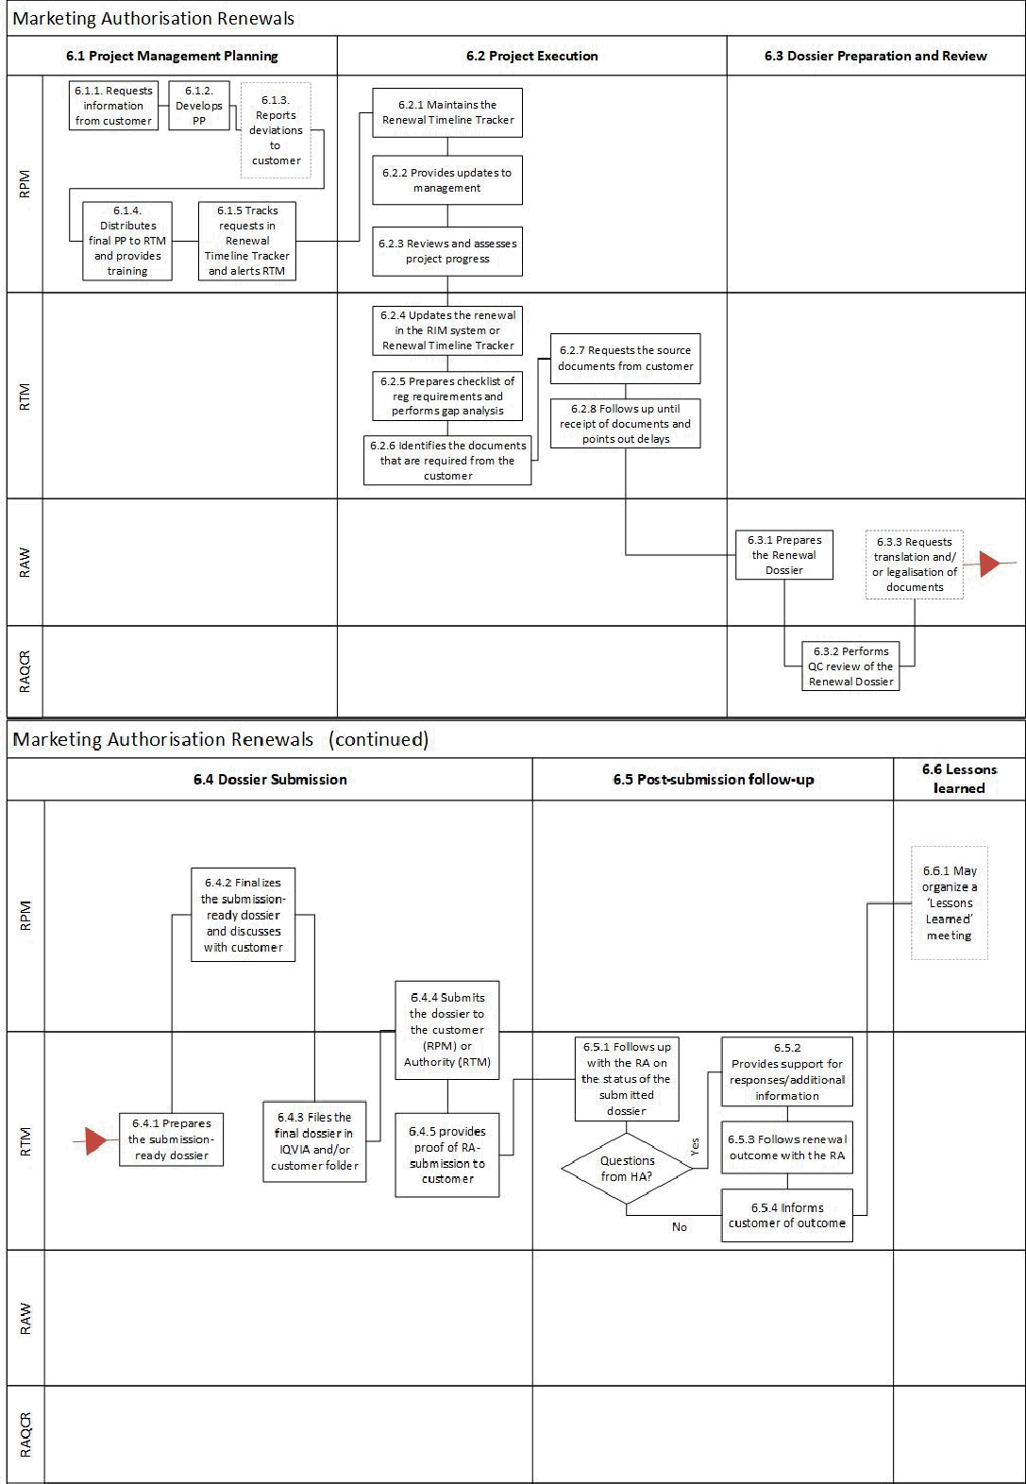

Page 6 of 6
Copyright © 2015, 2017, 2019, 2021. IQVIA. All rights reserved. The contents of this document are confidential and proprietary to IQVIA Holdings, Inc. and its subsidiaries. Unauthorized use, disclosure or reproduction is strictly prohibited.

UserName: Lobo, Zena (q833472) Title:
Date: Tuesday, 08 June 2021, 07:39 AM Eastern Time Meaning: Signing this Document Indicates My Approval
================================================

UserName: Corley, Helen (q730385) Title:
Date: Tuesday, 08 June 2021, 07:54 AM Eastern Time Meaning: Signing this Document Indicates My Approval
================================================

UserName: Glizer, Veronica (q735279) Title:
Date: Tuesday, 08 June 2021, 07:56 AM Eastern Time Meaning: Signing this Document Indicates My Approval
================================================

UserName: Galea, Claudine (q769301) Title:
Date: Tuesday, 08 June 2021, 08:57 AM Eastern Time Meaning: Signing this Document Indicates My Approval
================================================

UserName: Kemp, Jaco (q608126) Title:
Date: Tuesday, 08 June 2021, 09:14 AM Eastern Time Meaning: Signing this Document Indicates My Approval
================================================

UserName: Lewicky, Tamara (q730348) Title:
Date: Tuesday, 08 June 2021, 10:56 AM Eastern Time Meaning: Signing this Document Indicates My Approval
================================================

UserName: Balani, Tarun (q830700) Title:
Date: Wednesday, 09 June 2021, 01:25 AM Eastern Time Meaning: Signing this Document Indicates My Approval
================================================

UserName: Rahman, Maggie (q1033930) Title:
Date: Thursday, 10 June 2021, 01:15 PM Eastern Time Meaning: Signing this Document Indicates My Approval
================================================

